EASTERN AFRICA STATISTICAL TRAINING CENTRE
DSU07210 — Linux Systems Administration
Group Assignment Submission Template
Data Science Year 1 | Academic Year 2025/2026

A. Group & Assignment Information

Group & Assignment Details
Assignment No. | 05 | Session | C
Assignment Title | Linux Systems Administration
Group No. | 10 | Date Submitted | 7th June 2026
Academic Year
2025 / 2026

B. Group Members
List all group members. The Role/Task column should show which task(s) each member led.

# | Full Name | Reg. Number | Session | Role / Task
1 | FREDY RESPICHIUS MATUNGWA | EASTC/BDTS/26/04195 | 10 C | Led command 1 and 2
2 | TEKLA JOHN MKUDE | EASTC/BDTS/25/02469 | 10 C | Led command 3
3 | MARIA AGUSTINO KIKOTI | EASTC/BDTS/26/04694 | 10 C | Led command 4
4 | GLORY PETER SALUM | EASTC/BDTS/26/04583 | 10 C | Run command 5
5 | KELVIN EMANUEL SILVESTA | EASTC/BDTS/25/01903 | 10 C | Group organizer and creativity idea
6

C. Assignment Instructions Summary
Before starting, re-read the full assignment from your lecturer. Then tick the boxes below as you complete each task.

- Every command must be run on a real Linux terminal. √
- Screenshots or terminal recordings are required as evidence. √
- Complete the Creativity Challenge with a scenario your group designs. √
- Each member completes the Self-Exploration section individually. √
- Submit this template as your group report (printed or PDF).√
D. Task Completion Checklist
For each task: briefly describe what your group did, mark whether it is complete, and note the evidence (e.g. screenshot filename or page number in your terminal log).

# | Task Description (summarise what you did) | Done? (Yes/No) | Evidence
1 | We use df –h command to display data usage of all mounted filesytem and identify the roof partition | Yes done | 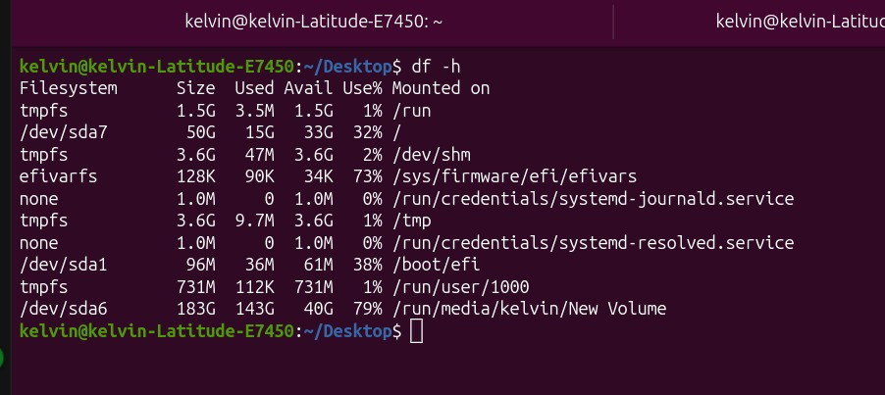
2 | We use command du –sh on different directories and compare their sizes | Yes done | 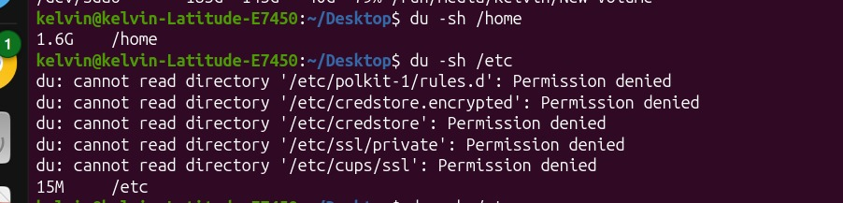
3 | Then we create a tz.gz achieve of a directory, we verify its contents with tar –tvf command, then we extract it to a new location | Yes done | 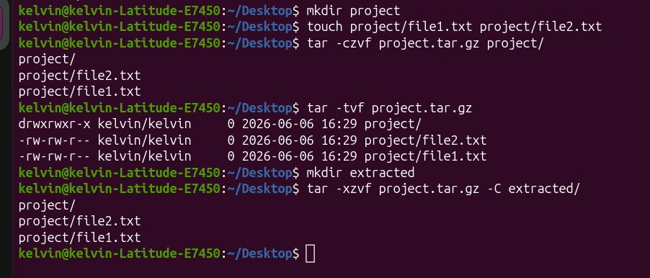
4 | We use lsblk command to list all block divices and describe the output | Yes done | 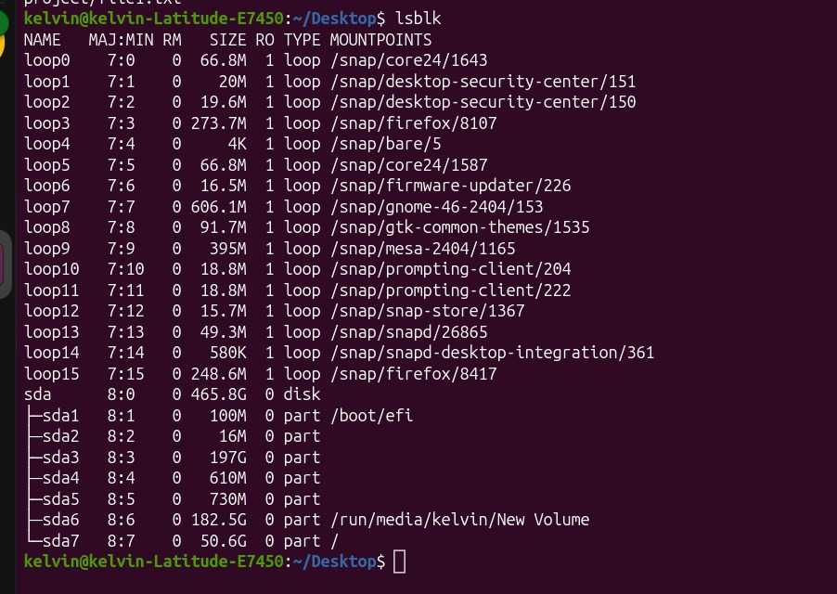
5 | Finally we compress a file with grip and then we compare its size before and after compress a file | Yes done | 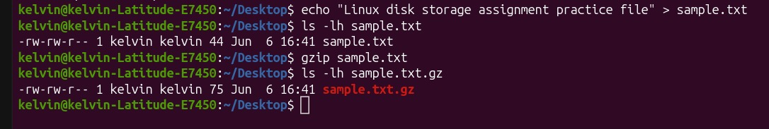

E. Command Evidence Log
Record the key commands your group ran. Attach screenshots after this page or include terminal output in an appendix.

# | Task Ref. | Command(s) Run / Description | Screenshot?
1 | Task 1 | Command: bash  df –h  (This diplay all mounted filesytems) | 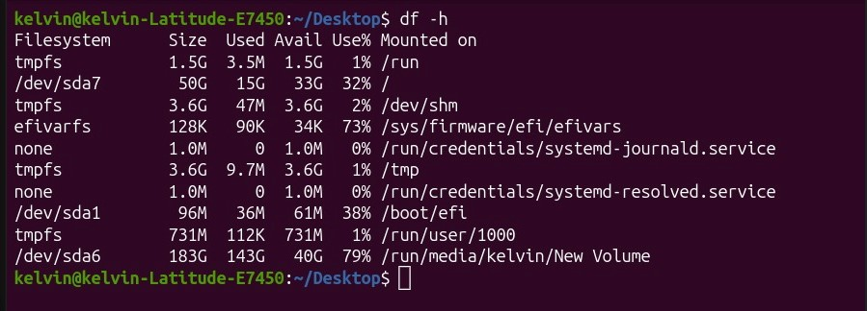
2 | Task 2 | Command: bash  du –sh Documents/Download/ Desktop/  ( This –s flag provide a summary total for each folder and –h make human-readable in MB or GB) | 
3 | Task 3 | Command: tar –czf backup.tar.gz Documents/  tar –tvf backup.tar.gz  tar -xzf backup.tar.gz –C /tmp/  ( These are used to create the archives, verify/list content without exctract and Extract to a new location respectivery ) | 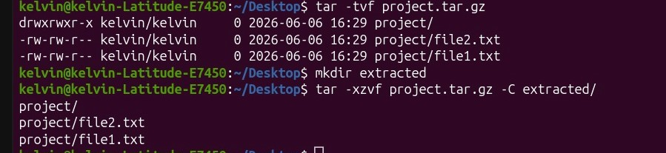
4 | Task4 | Command: lsblk  ( This show a visual tree of your storage divice like sda,sdb or nvme0n1 along their partitions) | 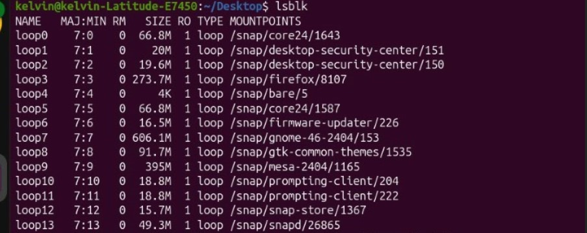
5 | Task 5 | Command:  gzip  ls –l large_file.txt  gzip large_file.txt  ls –l large_file.txt.gz  ( the command above used to compress a single file using gzip and compae size, check compressed file size) | 

F. Creativity Challenge
Describe the real-world scenario your group chose and explain your creative design decisions.

Creativity Challenge
Scenario we chose:
Backup Simulation
We created a backup archive:
tar -czf project_2025-06-01.tar.gz project/
Daily Cron Job
0 1 * * * tar -czf /backup/project_$(date +\%F).tar.gz /project
This command automatically creates a compressed backup every day at 1:00 AM.

Our creative approach:
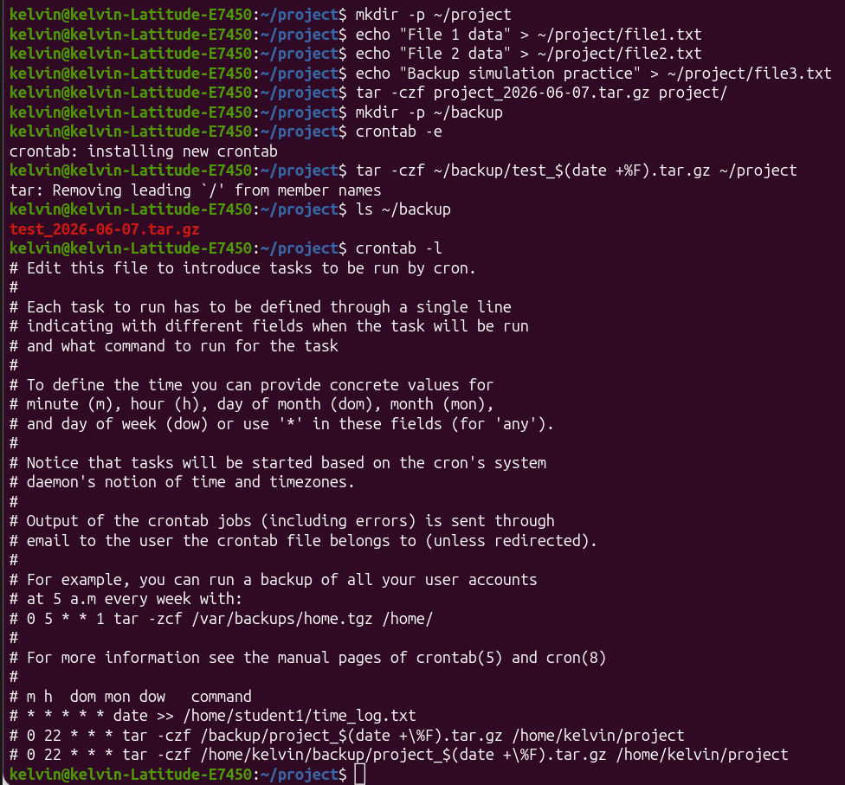

G. Self-Exploration (Individual — one per member)
Each group member must complete their own copy of this section. Photocopy this page or attach separate sheets — one per member.

Student Name: KELVIN EMANUEL SILVESTA Reg. No.: EASTC/BDTS/25/01903
Self-Exploration Findings
Exploration question answered:

Difference between tar -czf and tar -cjf

Key commands tested:
tar -czf
Uses Gzip compression.

tar -cjf
Uses Bzip2 compression.

What I discovered:
Gzip is faster.
Bzip2 usually creates smaller archives.
Bzip2 requires more processing time.

H. Group Member Contributions
Briefly describe what each member contributed. The percentages must add up to 100% per task (or you can distribute overall contribution).

Member Name | Specific Contribution | % Contribution
FREDY RESPICHIUS MATUNGWA | Run task 3 and 4 error verify | 20%
KELVIN EMANUEL SILVESTA | Lab supervisor and group organizer | 20%
GLORY PETER SALUM | Run task 5 and wrote report files | 20%
MARIA AGUSTINO KIKOTI | Run task 2 | 20%
TEKLA JOHN MKUDE | Run task 1 | 20%
J. Declaration
We declare that this is our own group work. All commands were run on a real Linux system. All members participated as recorded above. We have not copied work from another group.

Group Leader Signature:

Date: ____________________________

EASTC | DSU07210 Linux Systems Administration | 2025/2026

